Earthquakes Section 1 – Main Ideas

* Faults are huge cracks (miles long and deep) in earth along which the earth slips or displaces.
* Displacement of earth/rocks along a fault/crack releases energy in the form of EQ waves.
* Movement of the waves through earth causes earth to shake
* Locate origin of earthquake waves and faults using seismographs. Large faults = Big EQs

Branch of geology for earthquake studies is **geophysics**

* **Seismic** is a general term, describe movement of energy/waves
* Movement of the energy or waves is complex, but the energy can be described, measured, and sampled.
* A **seismograph** is used to sample and measure the waves/energy
* Sensitive instruments measure shaking around the world
* Study historical EQs so we can learn from the past.
* We learn **where** EQs occur, how big (magnitude and Richter scale), which types of buildings, roads etc., collapse, how much the earth shakes.
* Learn what people can do to prepare and plan etc.
* For comparison with the other EQs, a large event on the Wasatch Fault is expected to result in 1-3 meters of vertical displacement along a 30-50 km long segment of **normal fault**. This would cause a mag 7+ EQ.

What Causes EQs

* Stress builds as earth and plates move, **but plates stuck at faults/cracks in earth**
* Stress builds to the break point **at fault**
* Rocks upper 30 km of earth are brittle and **break at the fault**
* The stress/energy is released by breaking rock at fault and also sending energy /EQ waves
* The process repeats because **earth is dynamic** (**plate motion continues**)
* **The Parkfield Experiment** is a long-term earthquake research project on the San Andreas fault. The purpose is to better understand elastic rebound and what happens on the fault before, during and after an earthquake.
* **Hypothesis:** Moderate-size earthquakes of about magnitude 6 have occurred on the Parkfield section of the San Andreas Fault at regular intervals.
* Available data suggest all six Parkfield earthquakes are "characteristic" in the sense that they all ruptured the same area on the fault. If such characteristic ruptures occur regularly, then the next quake would have been due before 1993 – it happened in 2004. **USGS**

Earthquake Waves

* What is a wave? A disturbance that moves through a medium. Sound in the air….
* A wave is a means of moving or transferring energy from one point to another. Displacement on a fault generates energy that travels in a circular pattern around the fault.
* Concentrated energy spreads out or attenuates as it travels farther from the source. **This means that the farther you are from the fault, the less the earth will shake** (energy is spread over an area).

Seismograph – Earthquake wave measuring device

* A seismograph is a mass on a moveable support that detects horizontal and vertical ground motion, The mass stays in place as the frame or support moves. The difference in motion is recorded electronically. Time is also precisely recorded, so wave arrival times can be determined.
* Electronic recording makes the “detection limit” lower because the signal can be amplified so even minute vibrations can be measured and recorded.
* Very strong earthquakes are recorded directly by “strong motion accelerometers.” Automated to start upon certain amount of ground motion. Record the amount of ground acceleration (how much and how fast does the ground move…9.8 meters sec2…that’s huge!).
* Need 3 seismographs at each station to completely record motion in all 3 dimensions (X, Y and Z axis). For math lovers it’s a vector with magnitude and direction.
* P and S waves travel THROUGH earth and Love and Rayleigh/Surface waves travel AROUND the earth. All of these waves are represented on the seismogram.
* Each affects the recording device differently. For example, the lines are written more slowly or faster, increase in amplitude, wave rhythm changes
* With years of experience can pick out the different waves. Seismogram complicated due to reflection, refraction etc. in the earth.
* Need to filter out or ignore background (noise) traffic etc.. Example, P, S then Rayeigh at different times. Shows the need to very accurately record the time of arrival of the waves and duration of each wave. Use a standard time reference - Greenwich mean time.
* Example shows amplified record. Real ground motion for the S wave at this location was only 1/1000 of a centimeter. EQ occur near active faults. **Faults are caused by stress in earth, and the stress is mostly caused by or related to Plate Motion. Faults and plate boundaries are NOT the same thing.**

Locating Earthquakes (epicenter and focus)

* Some areas of the central USA are nearlyaseismic or earthquake free.
* Uncertainties – EQ have not been recorded “long” term. An area could have a history of large EQ every 1000 years and we don’t know. Good science acknowledges uncertainties or what we do not know“Scientific” type
* EQ study dates back to around 3000 years ago – Greeks, Chinese
* EQ Observatories – needed due to subjectivity of personal accounts of damage etc., and to record EQ in remote areas. Established around **1900**, but not too many recording stations or “sample points.” By 1960, 700 stations existed but EQ data not collected and evaluated consistently. In **1969** EQ recording and measurement was standardized. Now over 1000 observatories. Now all digital and computerized. – Data is now more independent, repeatable and credible because standardization allows data quality control (recall spike, duplicate example). science/technology example
* Waves radiate from source of EQ, energy spreads in volume of rock (crack in a wind shield)
* Focus – “point” of EQ origin in the earth. Fault is a plane not a point.
* Epicenter – point on surface above focus
* Aftershocks – smaller EQ that occur after main EQ. Caused by shifting of rocks along fault plane after main EQ. Important in mapping fault planes. Can be as large as one mag less than main EQ

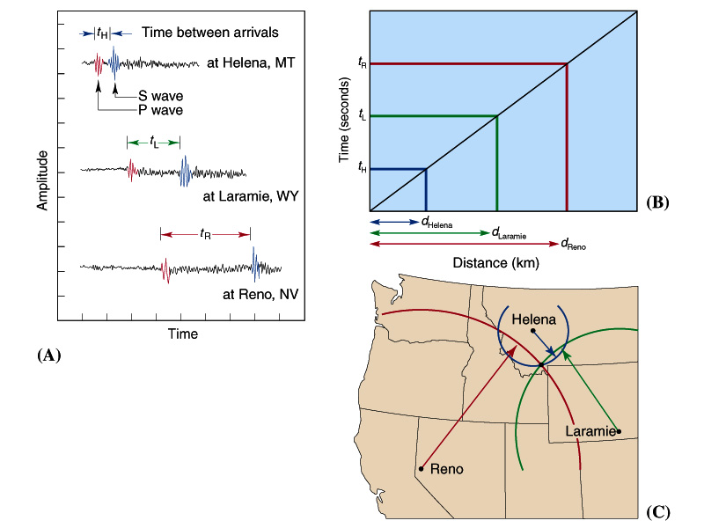

Size of Earthquakes and When EQs Occur

Intensity

Magnitude based on seismogram data

Magnitude based on Fault Size (Moment Magnitude)

Earthquake Recurrence (When)

* + Direct
  + Paleosesmology
  + Richter Relation
  + Assignment about recurrence
  + Earthquakes occur every day, but most are small – “**lots of small and few large EQs**”
  + Seismographs sample earthquake or wave energy (shaking)
  + The sample data (amount of shaking) is used to determine EQ size. **The closer you are to the fault the more the ground shakes.**
  + The average amount of time between large EQs occur is called the Recurrence Interval

**Intensity is an evaluation of the severity of ground motion, and is measured by the amount of damage**

* Intensity surveys are qualitative because the outcome of a damage survey depends on who does the survey, ground makeup and the population in the area.
  + A big EQ in a remote location could be rated low intensity (no one is around to report) or not be rated. Not a repeatable quantitative method
  + Intensity **VERY important in determining ways various structures and earth materials react to local shaking.**
  + **Used by engineers to design earthquake resistant structures. This information can also be used by government in zoning (i.e., not allow or restrict building in areas prone to liquifaction etc). USGS webpage. Did you feel it?**
  + Need a quantitative, less subjective way to measure EQ size. Worldwide Application. Record even small EQs.
  + **Wadati** of Japan and **Richter** of USA proposed using seismic wave amplitude as the standard measure of EQ magnitude.
  + Seismographs **take samples of EQ wave energy**. Using these “**energy samples**,” the size of an earthquake can be determined with one seismograph.
* **Standard** “Something set up and established by authority as a rule for the measure of quantity, weight, extent, value, or quality.” Webster online
* Convention: A general agreement about basic principles or procedures; *also* **:** a principle or procedure accepted as true or correct by convention” Webster online
* Based on data and measurements, Richter came up with a “convention” for measuring the sizes of earthquakes. People accepted his convention. Time and mm are standards used in this convention
* Because the size of EQs vary greatly and we can record even small amounts of shaking, the best way to measure and record EQ magnitude (ground shaking) is by using a logarithmic scale.
* There is a log relation between shaking and distance and the number and sizes of EQs, so the data suggest using logs..
* Thus, we get the two main ideas in seismology:
* The closer you are to a fault the more the earth shakes (used to make the Richter Scale); and
* There are lots of small earthquakes and only a few big ones. This main idea will be explored in the assignment for today.

Richter Scale: Convention/Method established by Charles Richter for reporting EQ size or magnitude is defined as:

* **“the logarithm to the base 10 of the maximum seismic wave (P,S or surface) amplitude (in thousandths of a millimeter) recorded on a standard seismograph at a distance of 100 km from the EQ epicenter.”**
* **Wave amplitudes are in log scale… The great thing about this method is an EQ magnitude can be determined using any One seismograph at any One location.**
* Shows the need for amplification in seismographs and the need for strong motion accelerometer
* The general idea behind the scale is:

***Richter Magnitude* = shaking (mm) + *Distance correction factor (time)***

*A* is the amplitude in millimeters measured from the seismogram. The *distance factor* is empirically determined and comes from a table that can be found in Richter's (1958) book [*Elementary Seismology*](http://www.amazon.com/exec/obidos/ASIN/0716702118/002-4319406-2041641). The equation behind the scale is:

* After measuring wave amplitude you have to take its [**logarithm**](http://www.seismo.unr.edu/ftp/pub/louie/class/100/logarithms.html), and scale it according to the distance of the seismometer from the earthquake, estimated by the S-P time difference. The equation more or less says: **“the closer you are to the fault the more the ground shakes!”**

EQ magnitude information is used in 3 main ways:

* General way to express size of an EQ
* A way to predict the ground acceleration in different locations – used in design and engineering of structure
* Can be used to map fault locations. Can record anything from magnitude minus 2 (brick dropped on the ground) to the 9.0 Indonesian EQ - one of the largest. Detection limits of seismograph provide wide range of “high quality” measurements. Above or below these detection limits data has less credibility.
* Most Accurate way to describe EQ magnitude … describe total energy it takes to beak the fault/rocks. Based on ***fault size***… the bigger the crack the more energy needed
* An EQ Magnitude value based on a measure of the total amount of energy is called Moment Magnitude.
* Moment is an energy term
* Mw is a mathematical model (not a convetion) based on fault size that relates fault size to the total amount of energy released in an EQ.
* Seismograms collect samples of the earthquake waves, but do not measure overall power/energy of the EQ source (example: can’t measure the total energy of a windstorm by measuring one gust)
* Energy of an earthquake is attenuated (spread out) as it travels through rock and soil. Mw leaves attenuation out and bases magnitude on fault size – **the larger the fault the larger the EQ**.
* How is the Mw model applied? The data needed to find Mw for a particular fault includes:
* **Fault length**
* **Fault width**
* **Fault displacement, and**
* **Rock strength or energy needed to break the rock (note: this value is empirically/experimentally determined)**

**When Do Earthquakes Happen – How Often**

* The **recurrence interval** is the time between large EQs.
* It is important to know the location of faults, the size EQ a fault may generate and how often EQs occur on a fault.
* In this class, the term “**characteristic earthquake**” means the maximum size earthquake that a certain fault will cause. The **Characteristic EQ for Wasatch is 7.**

**Three Methods**

* **Direct – Works for Faults such as Parkfield where EQs occur often – take an average**
* **Paleoseismology and Carbon Dating - average**
* **Richter Gutenberg – Assign 2**
* **Extrapolation - Use data about the recurrence of small earthquakes to estimate the recurrence interval of larger earthquakes**
* **Parkfield Recurrence**
* Years between Eqs
* 24+20+21+12+32+38
* = 24.5 average recurrence
* Last EQ was in 2004
* The next (min) 2018 to (max) 2042 – **ave 2028**
* **Paleoseismology** study of ancient EQs. Since movement on faults causes EQs, paleoseismologists study faults to see the size of earthquakes the fault may have caused in the past and may cause in the future.
* **This method used to study Wasatch Fault and *the Moment Magnitude model is used to estimate the size***
* Two main goals:
* **1) the recurrence interval and**
* **2) size of a “characteristic earthquake” for a certain fault.**

**Gutenberg Richter Relation**

* Richter Collected EQ magnitude data in CA and worldwide
* Data shows lots of small and few large EQs (main idea)
* log-linear relation for EQs in a certain area over certain time
* Roughly 10 times more 2 than 3, 10 times more 3 than 4 etc., The more data you have the better the fit.
* Relation is: log y = a – bx (equation of a line)

**Paleoseismology**

* **Seismographs** are used to determine the size and location of earthquakes. Can’t find the size or location of ancient earthquakes with a seismograph. This includes R-G.
* **Paleoseismology** is the study of ancient earthquakes. Since movement on faults causes earthquakes, paleoseismologists study faults to see the types of earthquakes they have generated or may generate in the future.

* Use the Moment Magnitude Model - data needed to find the size of the earthquakes with this model includes: the length and width of the fault, fault displacement and rock strength.
* The ages of the sediment layers and information about displacement information is obtained from trenching studies and can be used to find a recurrence interval.

**Determining Fault Type from FIRST MOTIONS on Seismograms**

* Seismograph data shows fault type
* Seismograms record direction of first motion on the fault
* If first motion is away, the seismograph records the P wave arrival as a dilation (down on the seismogram) and if the fault is moving toward the seismograph, the first motion of a P wave is recorded as a compression (up on the seismogram).
* If data from many seismograms is available, this data can be plotted and evaluated to determine the strike, dip and type of fault.
* The actual determination on most faults is complex, but movement can be graphically shown in a simple manner using “beachballs.”

**What can be Determined from Those Crazy Lines on Seismograms?**

Amount of ground shaking – wave amplitude

* Ground Acceleration and Engineering Info
* Types of earthquake waves
* Location of earthquake epicenter (3 seismographs)
* Size or Magnitude (1 seismograph)
* Fault depth (focus)
* Fault type (normal, strike-slip and thrust) beach ball
* Location of faults (previously unknown faults and better defined fault planes)

EQs, Tsunamis, Volcanoes and Landslides

* Earthquakes frequently occur before volcanic eruptions.
* Earthquakes preceded eruptions in Hawaii and at Mt. St. Helens and other volcanoes
* Earthquakes result due to movement of magma in the subsurface –
* Volcanic tremor, continual shaking of the earth for hours or days before eruptions
* Seismic sea waves are caused by displacement from faulting. Offset on a fault creates the wave by pushing the water above the fault upward.
* Tsunamis are big because they cause a large wavelength waves that affect water at great depth.
* Not Tidal waves. Only faults that rupture the surface cause tsunamis.



Earthquake Forecasting

* Rule #1 – No one can predict and EQ! Richter, developer of the eponymous magnitude scale, commented as follows in 1977: "Journalists and the general public rush to any suggestion of earthquake prediction like hogs toward a full trough... [Prediction] provides a happy hunting ground for amateurs, cranks, and outright publicity-seeking fakers". This comment still holds true. From USGS EQ webpage.

Probability Estimate

* Assume EQs are random events and can occur any day.
* Case 1 - Look forward from today.
* Case 2 - Use data showing how long it has been since the last EQ. Still assume random event, but now assume you are making the calculation starting the day after the last big EQ.
* Math Prediction Model: The historical earthquake method counts the number of earthquakes of a given magnitude within a region (say 10 magnitude 7 EQs over the last 100 years).
* The historical time period is then divided by the number of events to get the average recurrence interval (**100 years/10 eq = 10 years/EQ**).
* The inverse (i.e., **1/10 = 0.1**) of this average recurrence interval is the **earthquake occurrence rate per year. (N)**
* The probability **(p)** of an EQ in (**T)** years can then be estimated using:
* **p = 1 – e-(N*T)**, that is: e raised to the power of –(N*T)
* if N = 0.1 and T is 10 years then
* N*T = -1 and e(-1) = 0.36
* p = 1-0.36 = 0.64 or 64% chance of a magnitude 7 EQ in the next 10 years
* Good News! I will not test you on the probability model – just an example …

Wasatch Probability

* Use historical earthquake method based on trenching (16 magnitude 7 plus EQs over the last 5600 years).
* The historical time period (5600) divided by the number of events (16) gives an average recurrence interval (**5600 years/16 eq = 350 years/EQ**).
* The inverse (i.e., **1/350 = 0.003**) of this average recurrence interval is the earthquake occurrence rate per year.
* **Probability (p) = 1 - exp(-N*T)** N = number of mag 7 + EQs per year or 17/5600 = 0.0030 T = Take into account it has been 400 years since the last big EQ and project 100 years ahead = 500
* If N = .003 and T is 500 years then N*T = -500*0.003 = -1.5 and exp(-1.5) = 0.22
* p = 1-0.22 = 0.78 or a 78% chance of a magnitude 7+ EQ in the next 100 years

**Wasatch Fault Hazard Assessment and Forecast**

* The Wasatch Mountains and adjacent valleys were created by episodic movements of the Wasatch Fault (WF) over the last 15 million years.
* The WF strikes generally northwest along or near the base of mountains and runs through Ogden, SLC and Provo. The WF dips to the west under the valleys. The WF occurs near the WSU football stadium, under the U of U and near BYU.
* The WF is part of the Intermountain Seismic Belt (ISB), which is a region of high EQ activity. The ISB is 800 miles long from Montana to Arizona and includes the Yellowstone hotspot area. In Utah, the ISB represents the east side of the Basin and Range, where the crust is being extended and pulled apart.
* The WF is the largest and most active fault in the ISB. (Utah Geological Survey, 1996). The east side of Basin and Range (Wasatch Fault) is extending at rate of 1-3 mm/year (Smith, 2003) – **SO** Stress is building as it extends – Stress is periodically relieved by movement of the fault and a major earthquake.
* The Wasatch Fault is divided into five major segments (Brigham, Weber, SLC, Provo and Nephi). Each segment is about 20-40 miles long. **If there was vertical displacement of 1-3 meters on a segment it would produce a 7.0 + Mag. EQ.** (the data used to make this conclusion is from trench, topographic and seismic studies**).**
* The average repeat time for a big quake (or recurrence interval) for a **single segment is 1200-2600 years**, but the combined recurrence interval **for all segments is 350 years.** Its been 600 years since the last major quake on any segment (Utah Geologic Survey) and its been 2400 years since an EQ on the Brigham segment and 1300 years for the SLC segment. Which segment will break next?
* About 500 small (Magnitude 1-3) EQ/year occur in the Wasatch Front area. Only a handful are above ML-3. Data used to define the fault depth and width (location) in the subsurface.

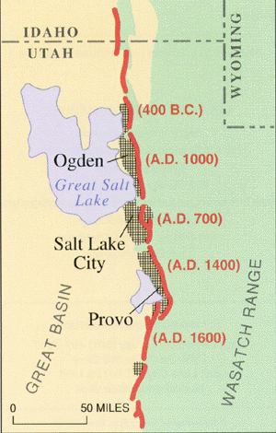

From Utah Geological Survey webpage

* **!**

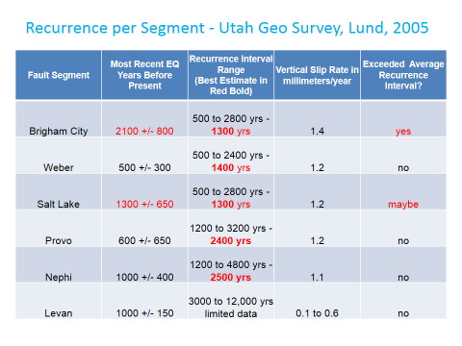

* Trench studies were used to develop recurrence interval info. Layers of carbon or other materials in the trenches were dated using the Carbon method.
* Based on these studies and assuming EQs are **random events** “the probability of an earthquake on the central segments is 25% in **100 years**.” (Utah Geological Survey);(random means it could happen any day - today or 50 years from now)
* Based on these studies the probability of an EQ on the Weber, Provo or Nephi segment is only about 10 % in the next 50 years.
* The probability on the Brigham or SLC segment is higher because the time since the last big EQ is equal to or greater than the average repeat time for that segment. On the and Brigham SLC segment, the probability may be as high as 57% in 100 years; (Utah Geological Survey).
* Strong ground shaking could cause damage in areas 50 miles from the fault.
* Ground shaking could be magnified up to 10 times in valley fill (loose soil) compared to rock
* Liquefaction, landslides and rock falls could cause major damage.
* Broad permanent tilting of the valley floor could cause Utah Lake or the Great SL to flood valley areas. Faults exist under the GSL. UGS

**Bottom Line: We know where and how big an EQ will be, and we have a general idea about when. This gives us the opportunity to prepare**